**Name: Chandana Ramesh Galgali Batch: B-4 Roll no: 16010422234**

**Tutorial Name: Tutorial 6 - Sampling using R**

**Date: 11 March 2024**

**Q.1 Test the significance of the difference between the means of two normal population with the same standard deviation from the following data.**

|  | **Size** | **Mean** | **St. Dev** |
| --- | --- | --- | --- |
| **Sample-1** | **1000** | **25** | **5** |
| **Sample-2** | **2000** | **23** | **7** |

**Code on Rstudio:**

sm1=25 # mean for sample 1

sm2=23 # mean for sample 2

sd1=5 # standard deviation of sample1

sd2=7 # standard deviation of sample2

n1=1000 # size of sample 1

n2=2000 # size of sample 2

zcal=abs((sm1-sm2)/sqrt((sd1^2/n2)+(sd2^2/n1)))

cat("Absolute value of z-calculated is =",zcal)

cat("Name & Roll No.:","Chandana Galgali & 16010422234")

**Output (screen shot):**

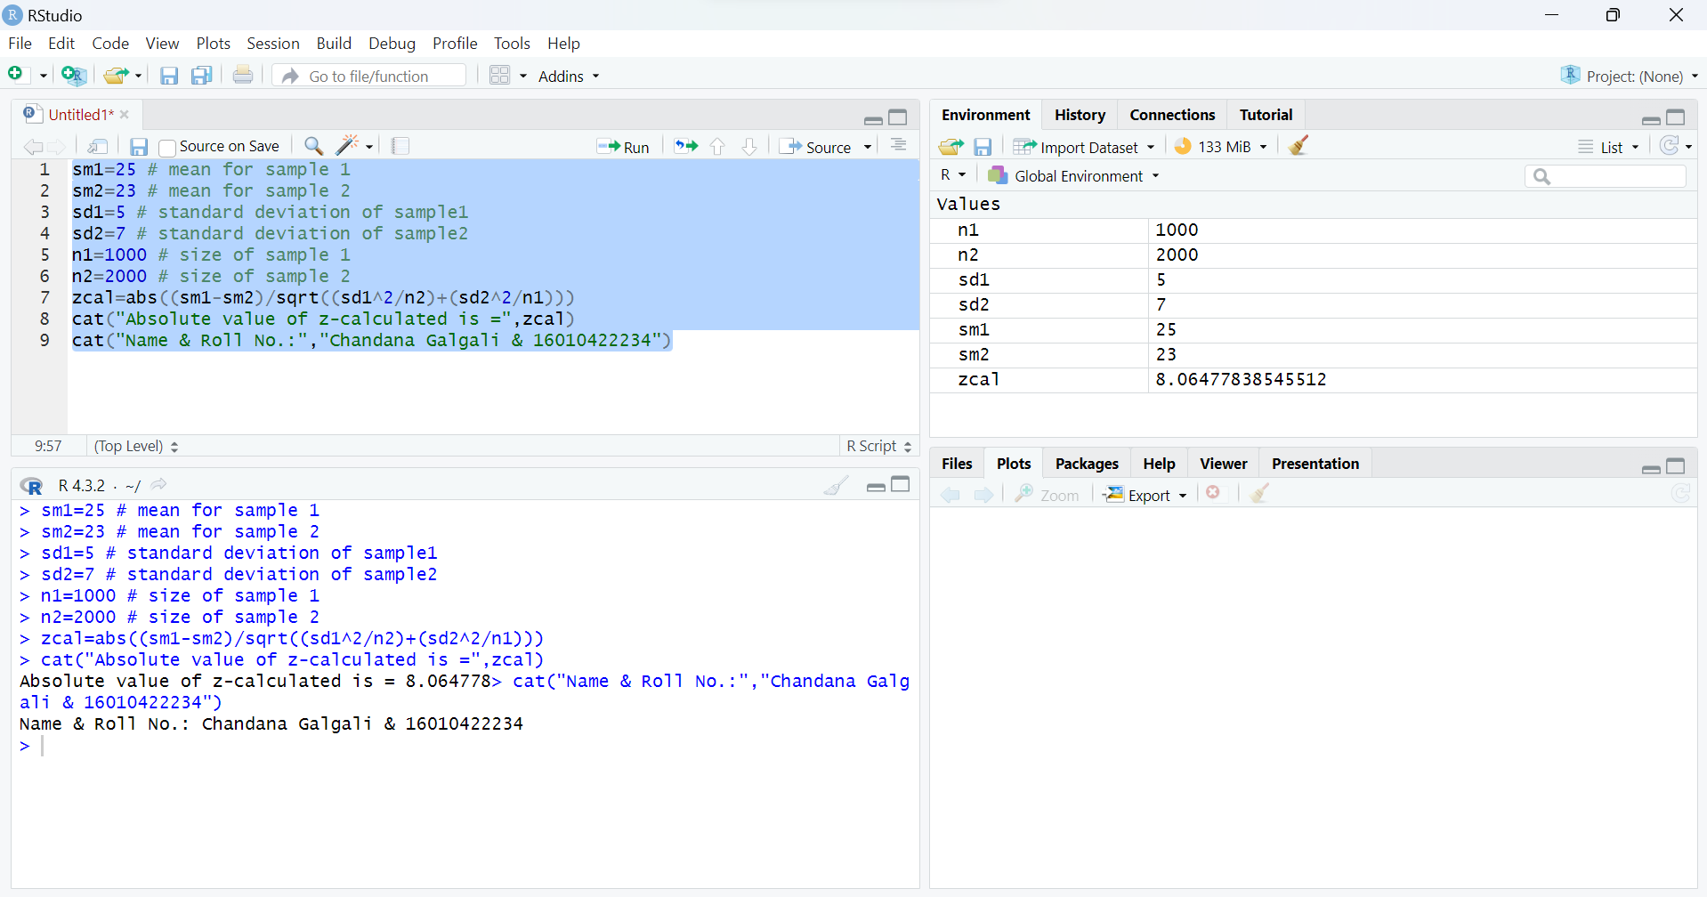

**Steps of Hypothesis Testing:**

1.

2. (Nature of the test is two tailed)

3. LOS is

4. Table value of is 1.96

5. Calculated value of

6. ; Therefore, is rejected

7. We can say that the difference between the population means is significant.

**Q.2. The weights of eight randomly selected athletes are recorded in kilograms: 70, 75, 78, 80, 82, 85, 87, 90. The weights of twelve randomly selected basketball players are recorded in kilograms: 72, 74, 76, 78, 79, 80, 82, 83, 84, 85, 87, 88. Can it be concluded that basketball players, on average, weigh more than athletes?**

**Code on Rstudio:**

x1 <- c(70, 75, 78, 80, 82, 85, 87, 90)

x2 <- c(72, 74, 76, 78, 79, 80, 82, 83, 84, 85, 87, 88)

sm1=mean(x1) # mean for sample 1

sm2=mean(x2) # mean for sample 2

sd1=sd(x1) # standard deviation of sample1

sd2=sd(x2) # standard deviation of sample2

n1=8 # size of sample 1

n2=12 # size of sample 2

tcal= abs((sm1-sm2)/sqrt(((n1*sd1^2+n2*sd2^2)/(n1+n2-2))*((1/n1)+(1/n2))))

cat("Absolute value of t-calculated is=",tcal)

cat("Name & Roll No.:","Chandana Galgali & 16010422234")

**Output (screen shot):**

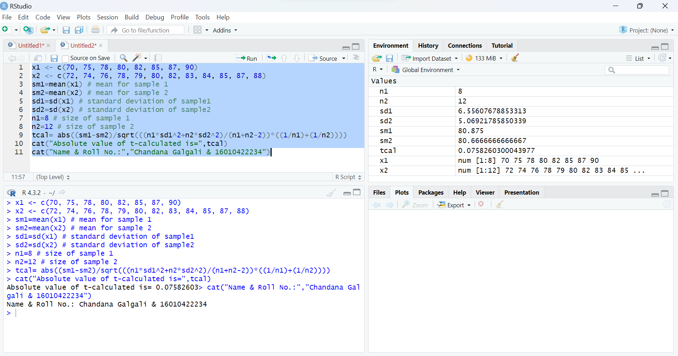

**Steps of Hypothesis Testing:**

1.

2. (Nature of the test is one tailed)

3. LOS is ,

4. Table value of is

5. Calculated value of

6. ; Therefore, $H0$ is accepted (left tailed test)

7. Therefore, it can not be concluded that the basketball players, on average, weigh more than the athletes.

**Q.3. A random sample of 300 observations has a mean of 15.5 kg. Can it be a random sample from a population whose mean is 16 kg and variance is 20 kg?**

**Code on Rstudio:**

pm=16 # population mean

sm=15.5 # sample mean

sd=sqrt(20) # standard deviation of sample or population

n=300 # size of sample

zcal=abs((sm-pm)/(sd/sqrt(n)))

cat("Absolute value of z-calculated is=",zcal)

cat("Name & Roll No.:","Chandana Galgali & 16010422234")

**Output (screen shot):**

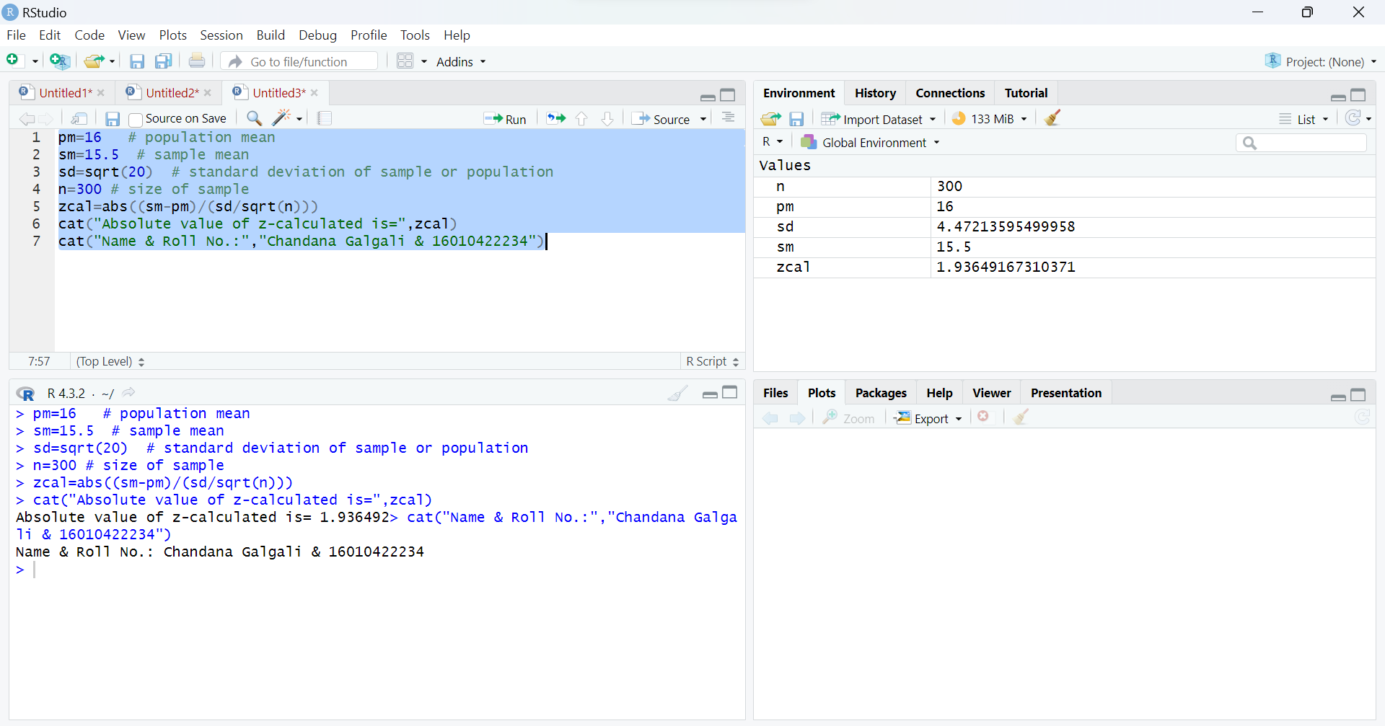

**Steps of Hypothesis Testing:**

1.

2. (Nature of the test is two tailed)

3. LOS is

4. Table value of is 1.96

5. Calculated value of

6. ; Therefore, is accepted

7. Therefore, we can say that the sample is drawn from a population with mean 16 kg and variance 20 kg.